SUGGESTED MORNING ROUTINE (Living as Energy book pub 2001)
Allowing our bodies to awaken naturally, giving all systems a chance to switch on and clear out, will greatly enhance our state of well living. Being mindful of the rising of Yang Qi with the dawn, the optimal time to awaken and arise, is also, with the sun. This is of course difficult if we choose to follow a path of willful disregard for the natural cycle, staying active into the regenerative phase of night - time.

The Chinese Clock diagram shows the times when the different organ systems experience their energy surges. It can be observed that morning is both the time of peak Yang/metabolic/digestive vigor, and the time the stomach and spleen/ pancreas energy is at its peak.
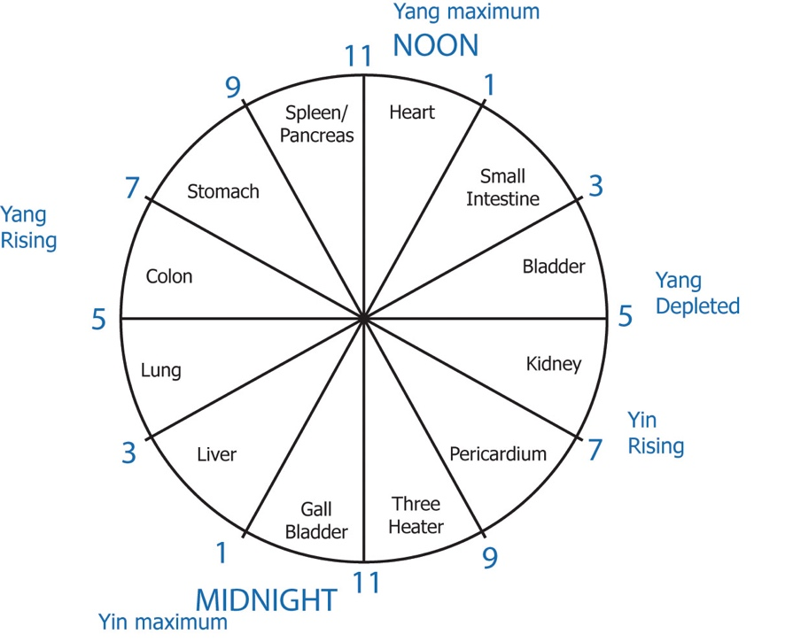
Eating a small, nutritious and easily digested meal early in the evening will allow the sleep cycle to regenerate your inner energy, hence Jing storage, thus assisting your continued good health.

- Stretch luxuriously, allow your consciousness to fully return here.
- Whilst still lying in bed, abdominal self-massage to help heal the inner organs, ensuring they can properly support you.
- Half a glass of warm water with half a lemon squeezed into it, to help the liver to wake up, and to thus activate the colon.
- Dry skin brush to assist the skin in its elimination of toxins from the inside out, and to waken the senses.
- Ten “Salutes to the Sun”, remembering to slowly breathe in on the stretching up and expanding movements.
- An enjoyable walk, or other exercise.
- A guided meditation, lasting between twenty to thirty minutes.
- A shower followed by a good body moisturiser, and a good cooked protein breakfast.

To look this over and laugh at the absurdity of it in your life is to exactly point out to you the issues to be faced in returning your system to optimal functioning.

Time for YOU – whose life is it?

