6 - Sustaining/Retaining Pregnancy (c)

This leads on from the series (a) and (b).
Seeing the major reasons the pregnancy/life may be faltering: we see categories:
Qi/Yang Depletion – see more here
Will also show up as low energy/thyroid function. The medical profession have possibly told you that you are ‘on the low range’/’OK’. Not so. Ideally your BBT would be 37.2/3 C at rest on awakening – and after at least 4 hours sleep. BUT it is likely that the whole horror of up and down to pee all night, pregnancy nausea and vomiting, can’t get comfy, ill all the time is part of your pregnancy journey as HEALTH is not happening and the medical route is not wellness orientated.

Seen as being a normal outcome as so few ARE well leading into building a new (thus alas weakened) person. Is this you?? This covers all possibilities and hopefully you are just starting down SOME of these trials.

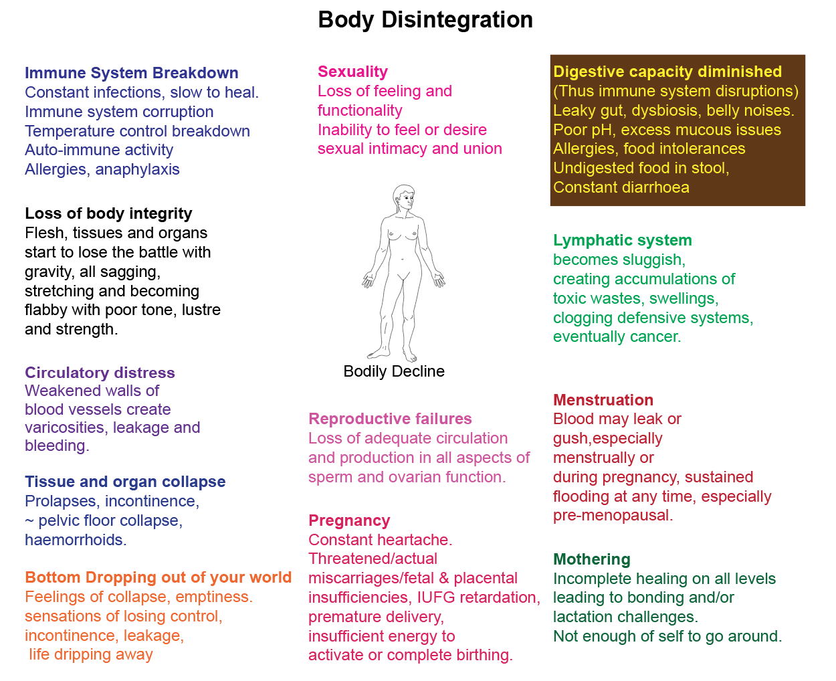

Whilst you may be scared looking at how accurate this is - also be aware that in pregnancy your body remakes itself – IF you let it. The energy and resources that are available to you could be siphoned off in other pursuits – or – you could choose LIFE and go for it – rebuilding your future and your child’s together.
Insufficient Jing – see more here. Jing is your inner bank account – what are you laying down for another? Can only make that baby once. Foundations are - as in building a house - foundational.

This is the essence of problems – not Living Well to begin with. Not valuing all that the ‘old wives tales’ would have had you live by. (‘Early to bed, early to rise’ etc). This Jing depletion progression will often show as inner heat (or potentially unwelcome pregnancy outcomes). It is totally repairable with great assistance and awareness that YOU are in charge of the results.

Please do not get reactive and think that this is a blaming game. Not your fault in that the modern focus is not on living quality lives.
At least drink at least 3 litres of unchilled pure (not tap) water daily – at least a litre prior to eating or drinking anything else. Low fluids and not enough minerals are the beginning of the Inner Heat and the Jing Depletion issues.

Here you have the benefit of my having worked with pregnancy and life force retrieval for over 40 years. In bridging the gap between what all knew - and automatically did at home (being oral traditions passed down through families) and the modern reliance on fee-for-service ill advised ‘medical’ takes on life.
These are not what got us to here. All traditions were life reverent. All followed the order of Nature. Survival of the Fittest is the only sustainable way. Here you see very different information - what works and always has. Following Nature.
Heat in the Blood – see more here
Will often show as bleeding out of turn, ‘high risk’ pregnancy complications - showing up ‘instantly’/ at the ‘last minute’. You may need a different health paradigm as the death avoidance medical one is not the best when breeding.
Stuck Blood – see more here
Will often show as pain in a fixed location and bleeding. Please seek natural health care all through your pregnancy – the holistic way is life enriching. You an completely turn your pregnancy outcome and future health and life around at this time not waiting for trouble – but insuring that it does not need to visit you.

Heart and pelvis disconnect (all that previous heart ache/break) – see more here
Broken hearts and fractured lives are often the platform your new conscious entry back into ‘the game of life’.

You may have a combination. These categories are not mutually exclusive. Aspects of all of these may be your current reality. Do not be alarmed – this is a health model. By being aware, you can work out for yourself - what to do.

Preparation time is past – salvage? Please read all the previous sheets/pages. As hard as it is . ..

You are now reaping what you sowed.

